**Intro to Bittensor**

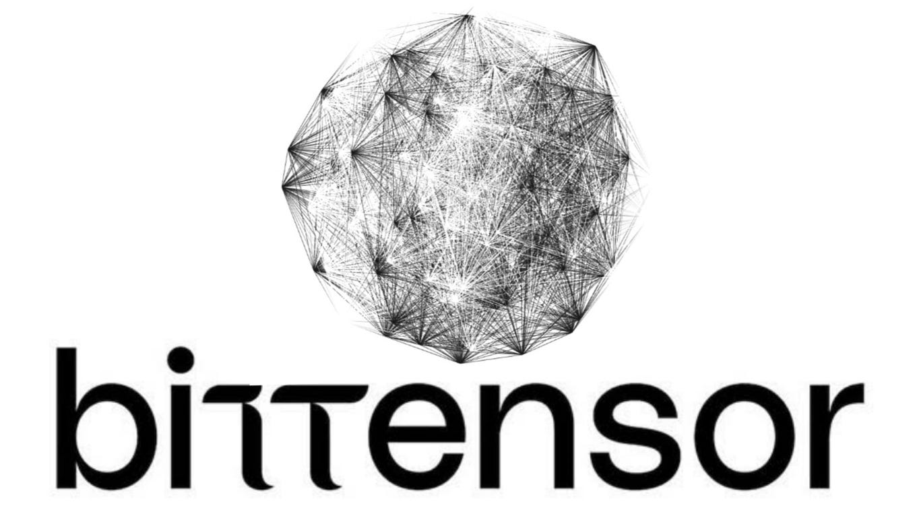

**My relationship with crypto**

When I evaluate an asset for my portfolio, I always start by building an investment thesis and then I carefully go through all the possible reasons why it could turn out to be wrong. In order to do this, I need access to information that’s both rich and reliable. That’s why, dear Lit Investor, **I’ve never been a big fan of crypto**.

Sure, plenty of people made money with Bitcoin and even more with Ethereum. But most of the time, what you hear are the few success stories, **not the countless scandals**. I still remember the shockwaves caused by FTX’s collapse, the pump-and-dump schemes of meme coins, the NFT craze and many other shady chapters that have always been part of the crypto world.

That said, my view on this asset class has changed over time, especially after I **came across** **the Bittensor ecosystem** in May of this year. Back then, I was already following AI developments closely and one day I stumbled upon a podcast about Bittensor.

It felt revolutionary. I spent days exploring their website, reading and rereading the whitepaper and diving deeper into the network. I didn’t know it yet, but I was about to fall into **the deepest rabbit hole** I had ever come across in finance.

**What is Bittensor**

If we asked ChatGPT, it would say that Bittensor is a decentralized network that brings AI and blockchain together, creating a global marketplace for machine learning models powered by its native token, TAO.

I’d also add that, through the development of open-source and permissionless solutions, Bittensor aims to democratize access to AI, breaking away from the centralization that usually defines Big Tech. And to me, that’s really the heart of the project.

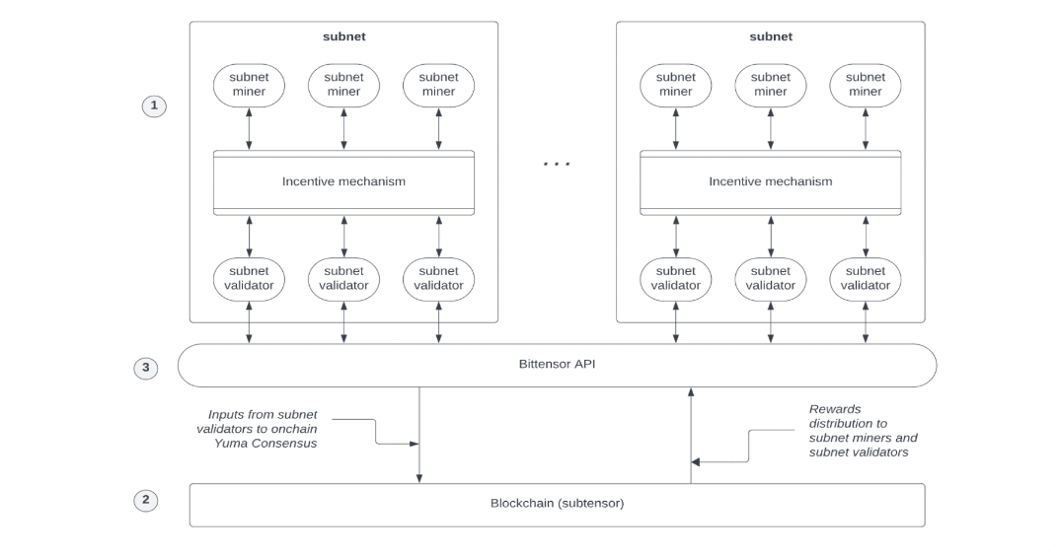

To understand how Bittensor works, it’s important to first define the following elements:

* **TAO**: the native token of Bittensor, used to incentivize participants and contribute value to the network. It also serves for staking, governance, and accessing AI services
* **Subnets (SN)**: specialized subnetworks within Bittensor, each focused on specific domains (e.g., natural language processing, predictive analytics, high-performance computing, audio/image generation). Within each subnet, there are ***owners*** who define the subnet and its goals, ***miners*** who perform the tasks, and ***validators*** who assess the quality of the miners’ output
* **Alpha Tokens**: tokens specific to each subnet, recently introduced to test internal reward mechanisms within the subnetworks
* **Proof of Intelligence (PoI)**: the mechanism for evaluating the contributions of each node within the network
* **Yuma Consensus**: the blockchain consensus system that translates PoI evaluations into economic rewards, ensuring that the most valuable nodes are fairly compensated.

Sounds interesting, doesn’t it? Essentially, it’s an ecosystem of specialized subnets, each structured with owners, validators and miners. By competing for tasks that are set by the owners, validated by the validators and executed by the miners, participants in the network are rewarded with newly issued tokens. These follow a Bitcoin-like emission cycle, with a halving every four years.

The system encourages competition between subnets and collaboration within each subnet. Access is permissionless, which attracts the best miners to the best performing subnets. So, the natural question is: which subnets are currently leading the way?

Below are some of the most interesting subnets in the Bittensor ecosystem:

* **Chutes (SN64)**: breakthrough serverless compute for AI at scale. Powering trillions of tokens per month, Chutes is the leading open-source, decentralized compute provider for deploying, scaling and running open-source models in production.
* **Ridges (SN62)**: market leader for software engineering agents running on open-source models. In its AI platform autonomous agents improve themselves through competitive coding, powered by contributions from top engineers
* **Lium.io (SN51):** innovative GPU marketplace. It operates as a rental platform that enables seamless access to GPU computing resources through a decentralized network, providing reliable and efficient solutions for computational needs.

**Bittensor’s drawbacks**

Currently, the Bittensor network includes 128 subnets, though not all of them are running at full capacity due to structural challenges.

First, designing an effective internal incentive system is no easy task. It requires careful balance between validators and miners, robust methods for measuring and managing economic incentives and mechanisms to retain the best operators over time.

Second, developing a financially sustainable business model is pretty complex, given the open-source nature of the AI products and services being built, along with competition from established centralized players that pour billions into CapEx every quarter.

Finally, dear Lit Investor, one issue is tied directly to the link Bittensor has with artificial intelligence itself. Right now, all eyes are on AI, and while this spotlight helped bring attention to initiatives like Bittensor throughout 2023 and 2024, going forward it could prove to be a double-edged sword for the ecosystem. If AI were to fall out of fashion, selling pressure on the TAO token could reduce the dollar value of incentives, undermining the entire network.

That said, Bittensor seems anything but unprepared for this challenge.

Appunti- non leggere

**Incentivizing intelligence with Bittensor**

Problemi: sistemi di monetizzazione

Nonostante il focus sia su AI, in realtà il valore reale di Bittensor è sul meccanismo di incentivo che permesse a menti ambiziose di avviare startup e progetti senza necessità di raccogliere un capitale ingente all’inzio.

<https://www.edwardconard.com/macro-roundup/paul-kedrosky-estimates-that-ai-capex-drove-20-to-40-of-us-gdp-growth-of-3-in-q2-for-practical-purposes-ai-capex-ate-q2-gdp-growth/?view=detail>



Dicono che Bitcoin aggredisce il mercato valutario e Bittensor aggredisce l’equity.

In un contesto economico in cui che le Mag7 fanno a gara a chi spende di più in Capex, le startup AI hanno valutazioni da bolla e sembra che non

per sviluppare la propria flotta di datacenter e supercomputer proprietari, sembra che nessuno si chieda più se questi investimenti siano realmente necessari. L’ecosistema Bittensor, attraverso alcune sue diramazioni, fornisce un po' una soluzione ad alcuni

Accelerazionismo (capitalismo estremo per il suo collasso)